Dear all,
in this document you will find information on how to reach Bologna Central Station, which is located close to the historic city centre.
Once you arrive at the airport, you have two ways to reach the station:
- The Marconi Express (a train that departs from the airport approximately every 10 minutes), costing €12.80 for a one-way ticket.
- Taking a taxi: the main taxi service in Bologna is COTABO, which you can contact by phone at +39 051 372727 or using the app (BTaxi). The fare varies depending on the number of passengers and traffic conditions. If you prefer this option, it is recommended to book the taxi a few days in advance, either by phone or through the app.
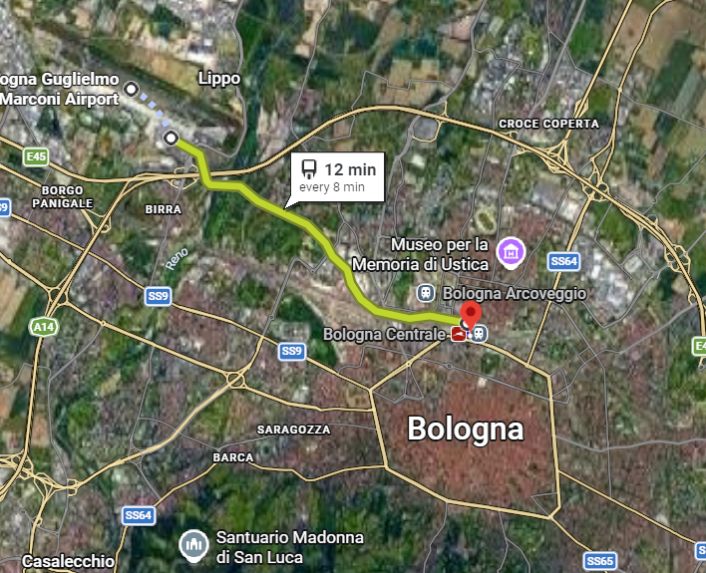
First option: Marconi Express

Second option: Taxi – travel times may vary depending on traffic.
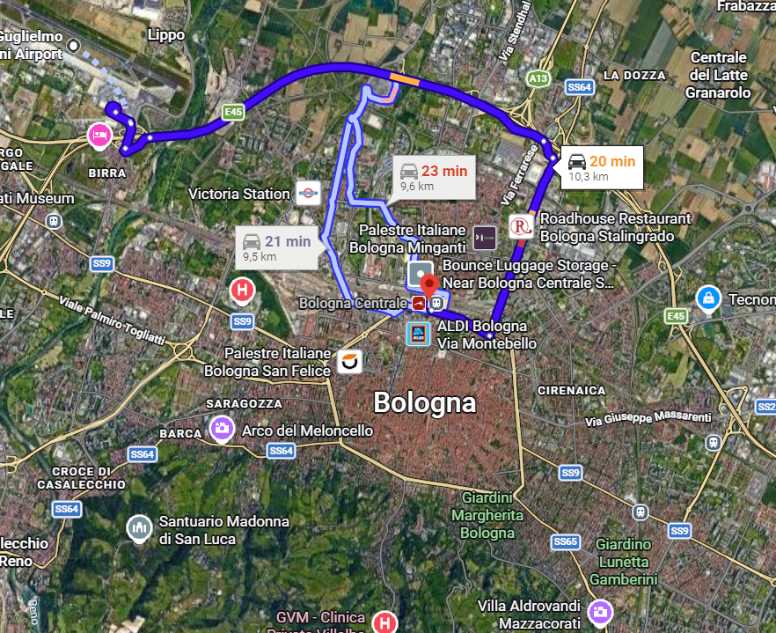

Once you arrive at the Central Station, you can reach the historic city center by walking (about a 10-minute walk), by taking a bus (lines 11A, 11B, and C) from the stops in front of the station, or by calling a COTABO taxi. The hotels we have selected are within walking distance from the station, so if you’re not running late 😉, you can enjoy a pleasant walk.
We would like to draw your attention to an important issue regarding your planned return date of August 2. On that date, the city of Bologna commemorates every year the anniversary of the 1980 bombing of Bologna Centrale railway station. As part of the anniversary, there are official ceremonies, a procession and other public events throughout the day, and traffic and transit in the city centre around the station can be affected by these commemorations.
Generally, the ceremony takes place during the morning, and normal train services are usually restored by early afternoon.
A link is provided below in case you would like to learn more!
https://it.wikipedia.org/wiki/Strage_di_Bologna

How to reach Sala Borsa from the train Station:
It is possible to reach Sala Borsa on foot (about a 20-minute walk) or by taking a bus (lines 25 and 30) from the Central Station, arriving at your destination in about 10 minutes depending on traffic.
How to reach DAMSlab from Sala Borsa:
From Sala Borsa, the recommended bus route to reach DAMSlab is line A, departing from the Ugo Bassi stop. Alternatively, it is possible to reach DAMSlab on foot (about 25 minutes).
Bus stops near DAMSLab:
- Don Minzoni – MAMbo, 3-minute walk from the DAMSLab (Lines 30, 36, 11, 87, 91, 94, 97);
- Piazza dei Martiri (Lines 40, 41, 61, 38);
- Rondone (Lines 18, 19, 23, 29, 33, 35, 86, 89);
- Porta Lame (Lines 18, 19, 23, 35, 671, 87, 61).

SUGGESTED HOTELS
Hotel Astoria (https://astoria.bo.it/it/hotel/)
Where is it: Via F.lli Rosselli, 14 40121 Bologna (BO)
In addition to standard rooms, the hotel also offers small apartments, perfect for already established groups! (The hotel can accommodate approximately 100 people).
Link for apartment reservations 🡪 https://appartamentiastoria.it/it/
Link for room reservations 🡪 https://astoria.bo.it/it/
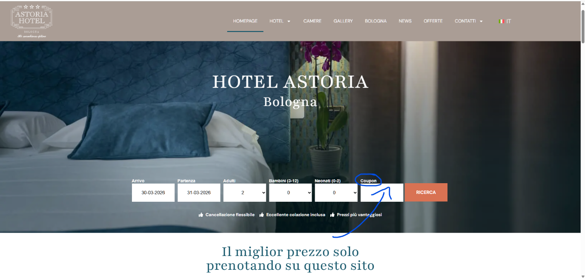
How to reach DAMS Lab and Sala Borsa from Hotel Astoria:
It is possible to reach the DAMS Lab by walking (about 10 minutes) or by taking a bus (around 15 minutes depending on traffic) from the Amendola stop (lines 11, 20, 29, and 30).
Sala Borsa can also be reached with a walk of about 20 minutes; alternatively, you can take a bus from the Amendola stop (lines A, 11, 25, and 30).

Royal hotel Carlton (https://www.royalhotelcarltonbologna.com/)
Where is it: Via Montebello 8 - 40121 Bologna

How to reach DAMS Lab and Sala Borsa from Royal hotel Carlton:
It is possible to reach the DAMS Lab by walking (10–12 minutes) or by taking a bus from the Milazzo/Mille stop (lines C, 36, and 15).
Sala Borsa can also be reached witha a walk of 15 minutes or, if you prefer, by bus from the same stop (lines A, C, 14, and 20), with a travel time of approximately 10 minutes.
HOTELS IN A STRATEGIC LOCATION FOR THE SEMINAR MEETING POINT
- Hotel Marconi Express 🡪
🡪

- https://www.hotelmarconiexpress.it
Hoter Mercure 🡪 https://all.accor.com/hotel/1310/index.it.shtml

B&BS
Room Breakfast Marconi Inn 🡪 https://www.marconiinn.it/
B&B Bologna Station 🡪 http://www.bolognastation.it/
B&B Ceci e Cleo 🡪 https://www.ceciecleo.it/it/
Triumvirato Rooms 🡪 https://www.triumviratorooms.it/
B&B Il Giardino 🡪 http://beb.it/ilgiardinolippo

If you decide to extend your stay by one day, below you’ll find some suggestions for places worth visiting!
If, after the seminar, you still feel like hearing more about archaeology, a visit to the Civic Archaeological Museum of Bologna is highly recommended.
https://www.museibologna.it/archeologico/
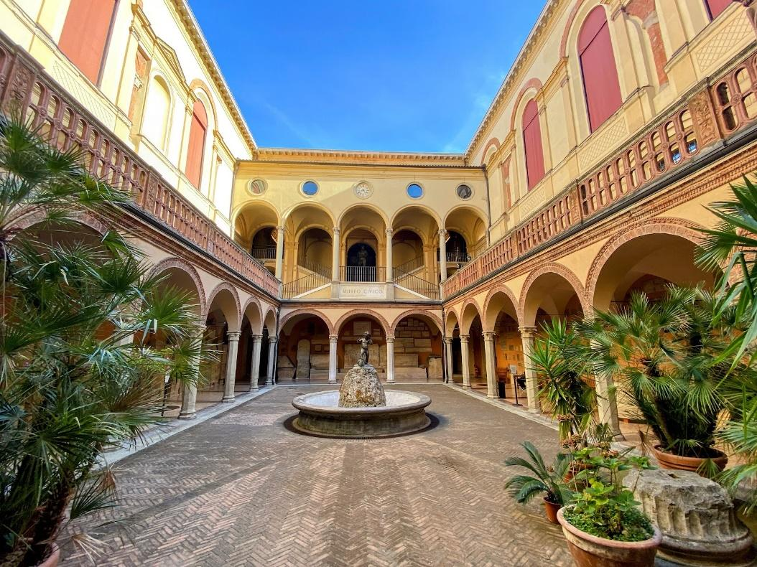

If you decide to spend the day in the city center, we also highly recommend visiting the Basilica of San Petronio and the Complex of the Seven Churches.
https://www.basilicadisanpetronio.org/
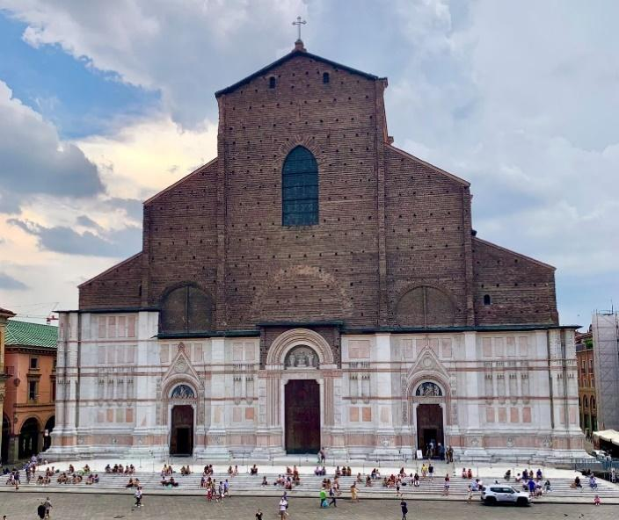
https://www.santostefanobologna.it/it/il-complesso-delle-7-chiese-di-santo-stefano/
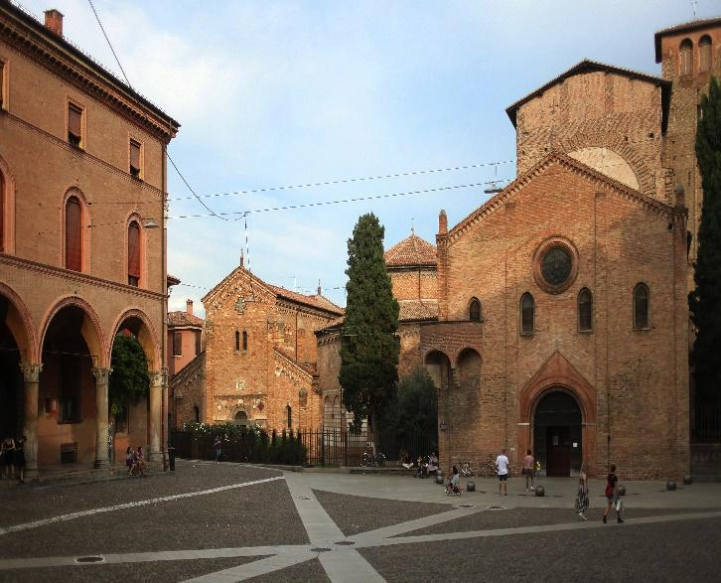

For the more adventurous, we suggest a visit to the Church of San Luca. The route to reach it is quite long but very scenic: you will walk about 3.8 km along covered arcades, which form the longest portico in Europe, and part of the path is uphill. But the view waiting for you at the top is absolutely worth it!
https://www.santuariodisanluca.it/
